**Incomplete**

**Step 1:** We will use the tool OurSecret which was provided in the #announcements channel on discord to extract data from given file.

OurSecret uses LSB replacement method for steganography and is a general purpose software that can be used for performing steganography for almost all file types like mp4,mp3,wav,png,jpg,bin and many more.

there is some text on the image provided which is a basic caesar cipher which translates to **SECRET MEETING AT THE PALACE**

On opening the image in OurSecret we use this as the password to extract flag file

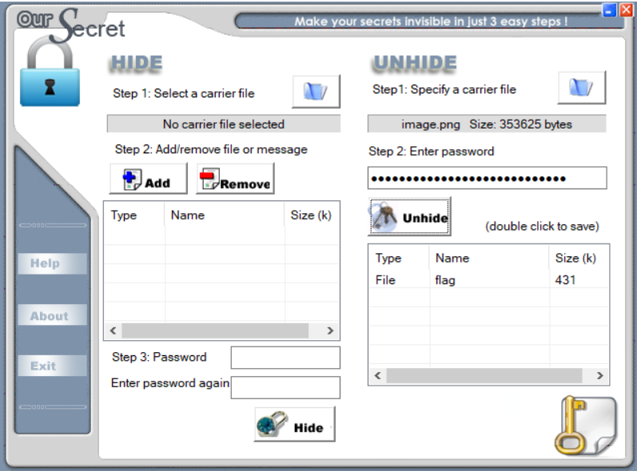

Then we move to step 2

**Step 2:** From the extracted “flag” file, determine the file format using “file <filename>” command.

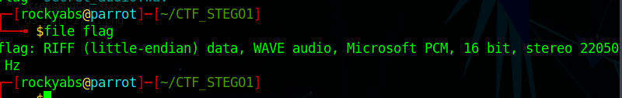

**Step 3:** Add the extension “.**mav**” to the **flag** file.

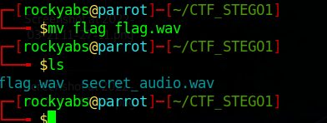

**Step 4:** Open any sound analyzer (E.g. Sonic visualizer) and open the “**flag.mav”** file in the analyzer.

**Step 5:** Go to pane and add “**Spectogram”** pane to see the flag.

